



Noteable Assignment Workflow Updates
Staff & student guidance
Exchange History, Bulk Autograding and nbgrader workflow guidance
Summer 2026 updates / Academic Year 2026–27
Noteable Assignment Workflow Updates 1
Staff & student guidance 1
Exchange History, Bulk Autograding and nbgrader workflow guidance 1
Summer 2026 updates / Academic Year 2026–27 1
1. Overview 1
2. Key terms 1
3. Due dates and submission timestamps 2
4. Exchange History 3
4.1. How instructors can use Exchange History 4
4.2. Download and Collect: the difference 4
4.3 Example: a student says they submitted before the deadline 5
4.4. Example: student submitted the wrong version 6
4.5 Example: Assignment not visible to students 6
4.6. Example 3: feedback unavailable to students 6
5. Bulk Autograding 6
5.1. Collecting submissions in Bulk Autograding 7
5.2. Running Bulk Autograde 7
5.3. Why Bulk Autograding is useful 7
5.4. Example: large assignment 7
6. Recommended instructor workflow 8
7. Support and issue reporting 8

1. Overview
Noteable includes new and updated instructor tools to support assignment management and marking workflows.
The main updates include:
- Exchange History tab available through the Nbgrader menu, which provides:
  - improved access to timestamped submissions;
  - clearer options to download or collect specific submissions;
  - better support for troubleshooting late, repeated or missing submissions.
- Bulk Autograding tab available through the Nbgrader menu, which provides:
  - an instructor-facing interface for collecting and autograding submissions for the current course, that lists assignments for the current course and shows:
    - the number of student submissions available in the assignment exchange;
    - the number of submissions already collected locally;
    - A Collect button and a Bulk Autograde button.
    - These tools support nbgrader-based assignment workflows in Noteable.

2. Key terms

Release
An assignment is released when it is made available to students through the assignment exchange.
Submit
A student submits an assignment when they send their completed work to the assignment exchange.
Collect
An instructor collects submissions when they bring student submissions from the assignment exchange into their local nbgrader course directory.
Download
An instructor downloads a submission when they copy a specific timestamped submission from the exchange into their Noteable home directory for inspection.
Autograde
Autograding runs the configured nbgrader tests and grading steps on collected submissions.

3. Due dates and submission timestamps
Instructors may configure due dates as part of their assignment setup. Submissions after a defined due date are not collected through the Formgrader, however they can be viewed and accessed in Exchange History.
Exchange History makes it easier to review submission activity around due dates. It can show whether a student submitted work before or after a deadline and whether they submitted more than one version.
This is useful where:
- a student says they submitted before the deadline;
- an instructor cannot see a submission in Formgrader;
- a student submitted more than once;
- a student submitted a version they did not intend to submit;
- an instructor wishes download a specific timestamped version for review, but keep it apart from the standard grading process.
- an instructor wishes to collect a submission that arrived after the due date
Exchange History allows instructors to view submission timestamps and, where appropriate, download or collect a specific version.

4. Exchange History
Exchange History provides a visual record of activity in the assignment exchange service.
It shows the courses a user has interacted with and the assignment exchange actions that have taken place, including:
- assignment releases;
- student submissions;
- collections;
- feedback release activity;
- feedback fetch activity.
The current course is highlighted in green and shown at the top of the list.
For each course, Exchange History shows:
- the first date of activity;
- the most recent date of activity;
- a summary of actions.
Clicking to expand an action shows individual events in time order.

4.1. How instructors can use Exchange History
Instructors can use Exchange History to check whether:
- an assignment has been released;
- students have submitted work;
- a specific student submission is present in the exchange;
- a student submitted before or after a due date;
- a student submitted more than once;
- collection activity has taken place;
- feedback has been released;
- students have fetched feedback.
This makes Exchange History especially useful for troubleshooting assignment workflows.

4.2. Download and Collect: the difference
Exchange History includes two important instructor options for submissions: Collect and Download.
Collect
Collect runs an nbgrader collect action on that specific submission of the assignment.
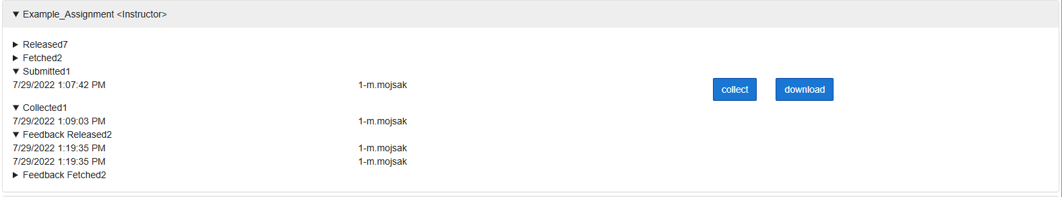

Download
Download will download the timestamped version of the assignment submission to the instructor’s Noteable home directory.
For example:
~/Downloads/<course_code>/<student>/<assignment>/
Use Download when you want to inspect a specific submission without changing the version currently held in the local nbgrader course directory.
Download is useful for:
- checking what a student submitted at a particular time;
- reviewing a disputed submission;
- comparing multiple submissions;
- preserving evidence of a timestamped version;
- inspecting a submission before deciding whether to collect it.

4.3 Example: a student says they submitted before the deadline
A student reports that they submitted an assignment before the due date, but the instructor cannot see it in Formgrader.
The instructor can:
- Open Exchange History.
- Select the relevant course.
- Find the relevant assignment.
- Look for the student’s submission.
- Check the timestamp.
- Download the timestamped version if they want to inspect it.
- Collect the timestamped version if it should be used for marking.
This helps distinguish between:
- no submission being present;
- a submission being present but not collected;
- a student submitting after the due date;
- multiple versions being submitted;
- the wrong version being collected by the instructor.

4.4. Example: student submitted the wrong version
A student submits an assignment and later reports that it was not the version they intended.
The instructor can use Exchange History to:
- Review the student’s timestamped submissions.
- Identify previous versions.
- Download versions for comparison if needed.
- Collect the appropriate version.
This allows instructors to work with specific versions rather than recollecting the whole assignment.

4.5 Example: Assignment not visible to students
Students report that an assignment is not available.
The instructor can use Exchange History to check whether the assignment release event exists in the exchange.
If no release event is present, the assignment may not have been released correctly.

4.6. Example 3: feedback unavailable to students
Students report that feedback is unavailable.
The instructor can use Exchange History to check whether feedback was released and whether students have fetched it.

5. Bulk Autograding
Bulk Autograding provides an instructor-facing interface for collecting and autograding submissions for the current course.
The Bulk Autograding page lists assignments for the current course and shows, for each assignment:
- the number of student submissions available in the assignment exchange;
- the number of submissions already collected locally;
- a Collect button;
- a Bulk Autograde button.
Output from collection and autogradiAutogradingis displayed below the assignment table.
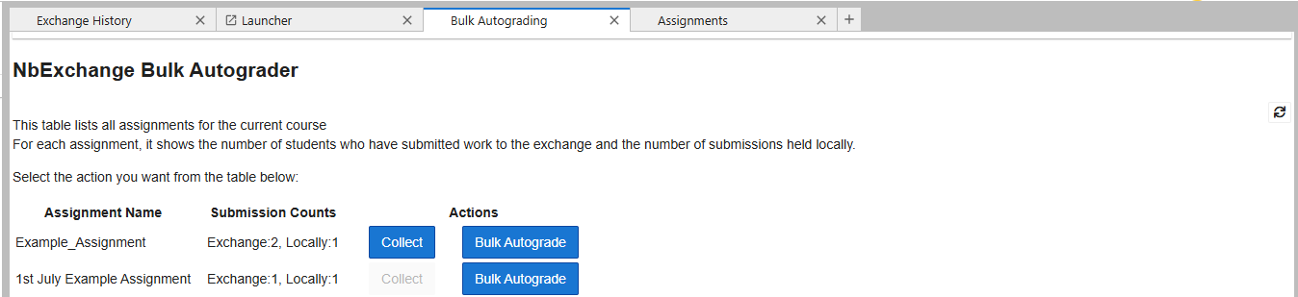

5.1. Collecting submissions in Bulk Autograding
The Collect button gathers available submissions from the assignment exchange into the instructor’s local nbgrader course directory.
It is disabled where there are no outstanding submissions to collect.
Use this when submissions are available in the exchange but have not yet been collected locally.

5.2. Running Bulk Autograde
The Bulk Autograde button runs autograding across the collected submissions for the selected assignment.
Bulk Autograding reports which submissions succeeded and which failed.
This is useful for larger cohorts and for assignments where individual submissions may contain errors that interrupt normal grading.

5.3. Why Bulk Autograding is useful
In the Formgrader workflow, a broken autograde step can stop the process and interrupt marking.
Bulk Autograding is more resilient. If one submission has a problem, the bulk process can continue processing the remaining submissions and report the failed case separately.
This helps instructors:
- avoid one problematic submission stalling the workflow;
- process larger numbers of submissions more efficiently;
- identify failed submissions clearly;
- return to failed cases after successful submissions have been processed.

5.4. Example: large assignment
An instructor has 120 submitted notebooks for a Python assignment.
In Bulk Autograding, they see:
- 118 submissions available in the exchange;
- 100 submissions already collected locally.
They select Collect to retrieve the remaining submissions and then run Bulk Autograde.
If one student submission fails to autograde cleanly, the process reports the failure but continues with the other submissions. The instructor can then review the failed case separately.

6. Recommended instructor workflow
Before marking:
- Confirm the assignment due date.
- Check that the assignment was released.
- Confirm submissions are present in the exchange.
- Use Bulk Autograding to collect available submissions.
- Run Bulk Autograde.
- Review the success/failure report.
- Use Exchange History to investigate missing, late or disputed submissions.
- Download specific timestamped versions where inspection is needed.
- Collect a specific timestamped version where it should replace the local copy.
- Release feedback when marking is complete.

7. Support and issue reporting
When reporting assignment workflow issues, include:
- your university username;
- the notebook environment used;
- the course or test area;
- assignment name;
- steps to reproduce the issue;
- screenshots or error messages;
Please report issues through the Noteable contact form: https://noteable.edina.ac.uk/contact-us/

